**ACID-BASE AND BUFFERS**

|  |  |  |  |
| --- | --- | --- | --- |
| ACID-BASE DEFINITIONS | | ACID | BASE |
| **1884** | **ARRHENIUS** | forms hydronium ion | forms hydroxide ion |
| **1923** | **BRØNSTED-LOWRY** | hydrogen ion donor | hydrogen ion acceptor |
| **1923** | **LEWIS** | electron pair acceptor | electron pair donor |

**ARRHENIUS**

* An acid is a substance that dissociates to give hydrogen ions when dissolved in water.
  + An acid dissociating in water does not form a free-floating proton. One of the water molecules in solution will grab the H+ yielding a hydronium or H3O+ ion.
* A base is a substance that disscociates into hydroxyl ions when dissolved in water.

ACIDS: Hydrochloric acid (HCl), Nitric acid (HNO3), Sulfuric acid (H2SO4), Acetic acid (CH3COOH or HCH3CO2)

BASES: Sodium hydroxide (NaOH), Potassium hydroxide (KOH), Magnesium hydroxide (Mg(OH)2)

**BRØNSTED-LOWRY**

* An acid is a compound that breaks down to give an H+ ion in solution. The solution does not have to be water. This applies to any aqueous solution.
* A base refers to any atom or ion capable of accepting or bonding to a free proton in solution. When an acid loses a proton, the residual part of it has a tendency to regain the proton. Hence, it behaves as a base. Such pair of substances which can be formed from one another by gain or loss of a proton is known as a conjugate acid-base pair.

acid base conjugate acid conjugate base

**HNO3 (aq) + NH3 --------------------> NH4+ (aq) + NO3- (aq)**

**LEWIS ACIDS AND BASES**

* + Lewis‘ definition deals with the movement of electrons.
  + The concept expands the list to include metal ions and other electron pair acceptors as acids.
* An acid refers to an atom or molecule that accepts an electron pair. Lewis acids are electrophilic or electron attracting. All cations are Lewis acids since they are able to accept electrons. (Cu2+, Fe2+, Fe3+)
* Lewis bases are electron pair donors. Anions can give up their e- electrons to an acid. (OH-, CN-, CH3COO-)

**pH : POWER OF HYDROGEN**

* Numerical representation of the acidity or basicity of a solution; can be used to do the calculation of te concentration of hydrogen ions [H+] or hydronium ions [H3O+] in an aqueous solution.
* **pH is the negative number to which the base 10 is raised to give H+ (proton)**

Negative log of molar hydrogen ion concentration, or molar hydrogen ion concentration equals 10 to the power of negative pH value.

**pH = -log [H+]**

1. **pH numbers are positive and have no units.**

* Most acids and bases have positive pH and fall within range 1-14.

1. **pH number is inversely related to [H+].**

* Solutions with a higher [H+] have a low pH. Strong acids have lower pH.

1. **A change of 1 pH represents 10 fold change in [H+].**

* Decreasing th pH by 1 unit represents a decrease in [H+] by 10 times.

A hydrogen ion, often written as H+, corresponds to a proton. Hydrogen ions exist in solution bound to water molecules, thus forming hydronium ions, H3O+.

**[H+] = 10-pH**

Sample Calculations:

**-log[H+] = 8.0**

**log[H+] = -8.0**

**[H+] = 1 x 10-8 M**

**-log[H+] = 3.0**

**log[H+] = -3.0**

**[H+] = 1 x 10-3 M**

**-log[H+] = 7.0**

**log[H+] = -7.0**

**[H+] = 1 x 10-7 M**

**-log[H+] = 11.0**

**log[H+] = -11.0**

**[H+] = 1 x 10-11 M**

**IONIZATION OF WATER**

* + Water dissociates into hydronium (H3O+) and hydroxyl (OH-) ions. For simplicity, we refer to the hydronium ion as a hydrogen ion (H+) and write the equilibrium as:

**H2O ⇌ H+ + OH-** The equilibrium constant Keq of this dissociation is given by

**Keq = [H+] [OH-] / [H2O] (1)**

in which the terms in brackets denote molar concentrations.

Because the concentration of water (55.5 M) is changed little by ionization, expression 1 can be simplified to give the equation in which Kw is the ion product of water. At 25**°**C, Kw is 1 x 10-14.

**Kw = [H+] [OH-] (2)**

Note that the concentrations of H+ and OH- are reciprocally related. If the concentration of H+ is high, then the concentration of OH- must be low, and vice versa. For example, if [H+**] =** 10-2 M, then [OH-**] =** 10-12 M.

**DEFINITION OF ACID AND BASE**

* An acid is a proton donor. A base is a proton acceptor.
* The species formed by the ionization of an acid is its conjugate base. Conversely, protonation of a base yields its conjugate acid. Acetic acid and acetate ion are a conjugate acid-base pair.

**ACID ⇌ H+ + BASE**

**CH3COOH (Acetic acid) ⇌ H+ + CH3COO- (Acetate)**

**NH4+ (Ammonium ion) ⇌ H+ + NH3 (Ammonia)**

**DEFINITION OF pH AND pK**

* The pH of a solution is a measure of its concentration of H+. The pH is defined as:

**pH = log10(1/[H+]) = -log10[H+] (3)**

The ionization equilibrium of a weak acid is given by:

**HA ⇌ H+ + A-**

The apparent equilibrium constant Ka for this ionization is:

**Ka = [H+] [A-] / [HA] (4)**

The pKa of an acid is defined as:

**pKa = -log Ka = log(1/Ka) (3)**

* Inspection of (4) shows that the pKa of an acid is the pH at which it is half dissociated, when [A-] = [HA].

**HENDERSON-HASSELBALCH EQUATION**

* What is the relation between pH and the ratio of acid to base? A useful expression can be derived from (4).

**1/[H+] = 1/Ka [A-] / [HA] (6)**

Taking the logarithm of both sides of equation (6) gives:

**log(1/[H+]) = log(1/Ka) + log ([A-]/[HA]) (7)**

Substituting pH for log(1/[H+]) and pKa for log(1/Ka) in (7) yields:

**pH = pKa + log ([A-]/[HA]) (8)**

which is commonly known as the Henderson-Hasselbalch equation.

* The pH of a solution can be calculated from (8) if the molar proportion of A- to HA and pKa of HA are known.

Consider a solution of 0.1 M acetic acid and 0.2 M acetate ion.

The pKa of acetic acid is 4.8. Hence, the pH of the solution is given by

**pH = 4.8 + log(0.2/0.1) = 4.8 + log 2.0 = 4.8 + 0.3 = 5.1**

The pKa of an acid can be calculated if the molar proportion of A- to HA and the pH of the solution is known.

**BUFFERS**

* An acid-base conjugate pair (such as acetic acid and acetate ion) has an important property; it resists changes in the pH of a solution. In other words, it acts as a buffer.
* A buffer is a solution that can resist pH change upon the addition of an acidic or basic components. It is able to neutralize small amounts of added acid or base, thus maintaining the pH of the solution relatively stable. This is important for processes and/or reactions which require specific and stable pH ranges.
* Buffer solutions have a working pH range and capacity which dictate how much acid/base can be neutralized before pH changes, and the amount by which it will change.
* To effectively maintain a pH range, a buffer must consist of a weak conjugate acid-base pair, meaning either a. a weak acid and its conjugate base, or b. a weak base and its conjugate acid. The use of one or the other will simply depend upon the desired pH when preparing the buffer. For example, the following could function as buffers when together in solution:
  + Acetic acid (weak organic acid with formula CH3COOH) and a salt containing its conjugate base, the acetate anion (CH3COO-), such as sodium acetate (CH3COONa)
  + Pyridine (weak base with formula C5H5N) and a salt containing its conjugate acid, the pyridinium cation (C5H5NH+), such as pyridinium chloride.
  + Ammonia (weak base with formula NH3) and a salt containing its conjugate acid, the ammonium cation, such as Ammonium Hydroxide (NH4OH).

Consider the addition of OH- to a solution of acetic acid (HA).

**HA + OH- ⇌ A- + H2O**

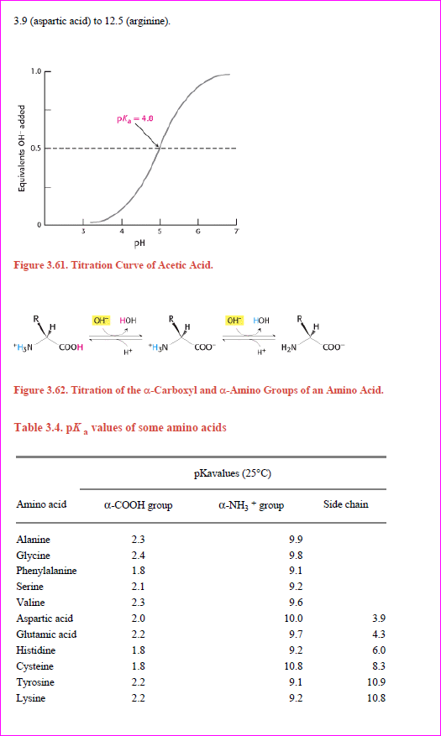

**TITRATION CURVE**

* plot of the dependence of the pH of this solution on the amount of OH- added

There is an inflection point in the curve at pH 4.8, which is the pKa of acetic acid. In the vicinity of this pH, a relatively large amount of OH- produces little change in pH.

In other words, the buffer maintains the value of pH near a given value, despite the addition of other either protons or hydroxide ions.

In general a weak acid is most effective in buffering against pH changes in the vicinity of its pKa value.

**pKa VALUES OF AMINO ACIDS**

* An amino acid such as glycine contains two ionizable groups:
  + an α-carboxyl group and
  + a protonated α-amino group.
* As base is added these two groups are titrated (figure 3.62).





The pKa of the α-COOH group is 2.4, whereas that of the α-NH3+ group is 9.8.

The pKa values of these groups in other amino acids are similar (table below).

Some amino acids, such as aspartic acid, also contain an ionizable side chain.

The pKa values of ionizable side chains in amino acids range from 3.9 (aspartic acid) to 12.5 (arginine).

**Lawrence Joseph Henderson (1878-1942)**

was a talented biochemist, among many other titles, who spent most of his career at Harvard. He was responsible for developing the components of the equation after studying equilibrium reactions that took place within blood as a result of respiration (specializing in "fatigue"). His equation was incomplete without the solid calculations into it provided by Hasselbalch.

**Karl Albert Hasselbalch (1874-1962)**

was a chemist who studied pH closely. He also studied blood and reactions that took place with oxygen, to put in the simplest of terms. He eventually modified Henderson's equation by putting mathematical logs into it creating a solid relationship.

**pH METER**

* A pH meter is an electronic instrument used for measuring the pH (acidity or alkalinity) of a liquid (though special probes are sometimes used to measure the pH of semi-solid substances).
* A typical pH meter consists of special measuring probes (a glass electrode and a reference electrode) connected to an electronic meter that measures and displays the pH reading.

**PRINCIPLE**

* pH is defined as the negative logarithm of hydrogen ion concentration.
* The pH, or power of Hydrogen, of a solution can be measured by the pH meter. The glass electrode is a half cell and the calomel electrode is another half cell.

**The following reactions take place in the electrodes:**

The glass electrode contains Ag, AgCl, and HCl. All these remain in the ionized state.

**Ag ⇌ Ag+ + e- AgCl ⇌ Ag+ + Cl- HCl ⇌ H+ + Cl-**

All the above three equilibrium reactions are balanced. In the glass electrode, H+ is generated.

The calomel or reference electrode contains Hg, Hg2Cl2, and KCl.

**Hg ⇌ Hg+ + e- Hg2Cl2 ⇌ 2Hg+ + 2Cl- KCl ⇌ K+ + Cl-**

All the above three equilibrium reactions are balanced. In the calomel electrode, H+ is not generated.

**DIFFERENT pH VALUES**

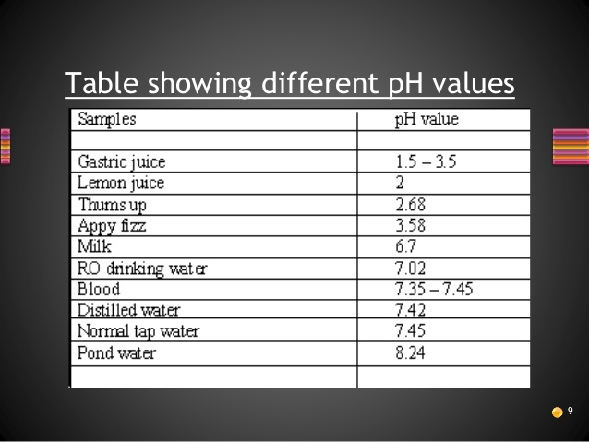

**CALIBRATION**

* Calibration should be performed with at least two standard buffer solutions that span the range of pH values to be measured.
* For general purposes buffers at pH 4 and pH 10 are acceptable.
* The pH meter has one control (calibrate) to set the meter reading equal to the value of the first standard buffer and a second control (slope) which is used to adjust the meter reading to the value of the second buffer.
* A third control allows the temperature to be set.

**MEASUREMENT OF pH**

1. The zero of the dial is set mechanically.
2. The knob for temperature compensation is fixed for the temperature of the solution.
3. The electrodes are dipped into a standard buffer solution of known pH.
4. Adjustment is made so that the dial reads the value of the buffer solution.
5. The electrodes are removed and washed well with distilled water.
6. The electrodes are dipped into the sample solutions.
7. The dial shows the pH value of the sample solution.

**APPLICATIONS OF pH METER**

* pH meter may be used for the diagnosis of various disorders in human body, for agriculture, brewing, corrosion prevention, dyeing, jam and jelly manufacturing, for printing, and for pharmaceuticals.
* **A pH meter is an electronic instrument used for measuring the pH of a liquid / semi-solid substances. We exploited the properties of this indicator to determine with precision the acidity or alkalinity of various substances. pH meter is more useful than the other pH indicators because it gives accurate reading (e.g. for detection of blood pH) and can measure the pH of a liquid as well as a semi-solid substance.**

**WORKING OF A pH METER**

* The electrode that does the most important job, which is called the glass electrode, has a silver-based electrical wire suspended in a solution of potassium chloride, contained inside a thin bulb (or membrane) made from a special glass containing metal salts (typically compounds of sodium and calcium). The other electrode is called the reference electrode and has a potassium chloride wire suspended in a solution of potassium chloride.
* The potassium chloride inside the glass electrode (shown here colored orange) is a neutral solution with a pH of 7, so it contains a certain amount of hydrogen ions (H+). Suppose the unknown solution you're testing (blue) is much more acidic, so it contains a lot more hydrogen ions. What the glass electrode does is to measure the difference in pH between the orange solution and the blue solution by measuring the difference in the voltages their hydrogen ions produce. Since we know the pH of the orange solution (7), we can figure out the pH of the blue solution.

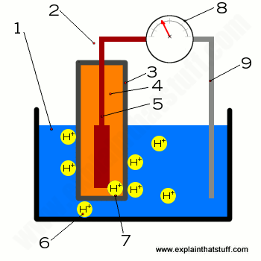**(1)** Solution being tested; **(2)** Glass electrode, consisting of **(3)** a thin layer of silica glass containing metal salts, inside which there is a potassium chloride solution **(4)** and an internal electrode **(5)** made from silver/silver chloride. **(6)** Hydrogen ions formed in the test solution interact with the outer surface of the glass. **(7)** Hydrogen ions formed in the potassium chloride solution interact with the inside surface of the glass. **(8)** The meter measures the difference in voltage between the two sides of the glass and converts this "potential difference" into a pH reading. **(9)** Reference electrode acts as a baseline or reference for the measurement—or you can think of it as simply completing the circuit.

* When you dip the two electrodes into the blue test solution, some of the hydrogen ions move toward the outer surface of the glass electrode and replace some of the metal ions inside it, while some of the metal ions move from the glass electrode into the blue solution. This ion-swapping process is called **ion exchange**, and it's the key to how a glass electrode works. Ion-swapping also takes place on the inside surface of the glass electrode from the orange solution. The two solutions on either side of the glass have different acidity, so a different amount of ion-swapping takes place on the two sides of the glass. This creates a different degree of **hydrogen-ion activity** on the two surfaces of the glass, which means a different amount of electrical charge builds up on them. This charge difference means a tiny voltage (sometimes called a **potential difference**, typically a few tens or hundreds of millivolts) appears between the two sides of the glass, which produces a difference in voltage between the silver electrode (5) and the reference electrode (8) that shows up as a measurement on the meter.

**MODERN pH PROBE DESIGN**

* A typical modern pH probe is a combination electrode, which combines both the glass and reference electrodes into one body. The combination electrode consists of the following parts:

1. 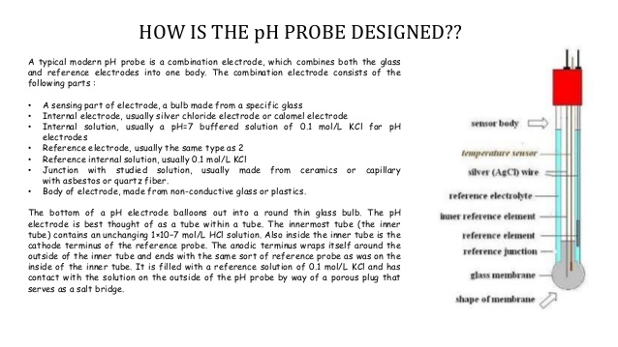A sending part of electrode, a bulb made from a specific glass
2. Internal electrode, usually silver chloride electrode or calomel electrode
3. Internal solution, usually a pH = 7 buffered solution of 0.1 mol/L KCl for pH electrodes
4. Reference electrode, usually the same type as 2
5. Refernce internal solution, usually 0.1 mol/L KCl
6. Junction with studied solution, usually made from ceramics or capillary with asbestos or quartz fiber
7. Body of electrode, made from non-conductive glass or plastics

* The bottom of a pH electrode balloons out into a round thin glass bulb. The pH electrode is best thought of as a tube within a tube. The innermost tube (the inner tube) contains an unchanging 1 x 10-7 M or mol/L HCl solution. Also inside the inner tube is the cathode terminus of the reference probe. The anodic terminus wraps itself around the outside of the inner tube and ends with the same sort of

reference probe as was on the inside of the inner tube. It is filled with a reference solution of 0.1 mol/L KCl and has contact with the solution on the outside of the pH probe by way of a porous plug that serves as a salt bridge.

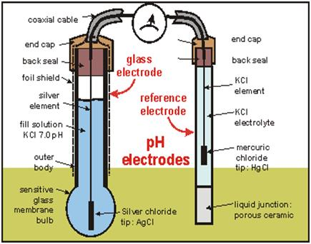

* The potential difference relevant to pH measurement builds up across the outside glass/solution interface marked ||

**AgCl(s) | KCl(aq) || 1×10-7M H+ solution || glass membrane || Test Solution || ceramic junction || KCl(aq) | AgCl(s) | Ag(s)**

**Ag/AgCl | HCl | glass || probed solution | reference electrode**

* The bulb is sealed to a thicker glass or plastic tube, and filled, for example, with a solution of HCl (0.1 mol/dm3). In this solution is immersed a silver/silver chloride electrode with a lead to the outside through a permanent hermetic seal. The filling solution has constant Cl- concentration, which keeps the Ag/AgCl inner electrode at fixed potential.
* The pH sensing ability of the glass electrode stems from the ion exchange property of its glass membrane.
* Glass is mostly amorphous silicon dioxide, with embedded oxides of alkali metals. When the surface of glass is exposed to water, some Si–O- groups become protonated.

**Si-O- + H3O+ ≡ Si-O-H+ + H2O (2)**

* The exchange of hydronium (or written as proton, H+) between the solid membrane and the surrounding solution, and the equilibrium nature of this exchange, is the key principle of H3O+ sensing. As with any interface separating two phases between which ionic exchange equilibrium is established, the glass membrane/solution interface becomes the site of a potential difference.

**Eglass electrode = E‘ + RT/2.303F log a(H3O+)**

* Where E’ represents the sum of the constant offset potentials of the inner glass surface/solution and the two Ag/AgCl electrodes. At 30°C the potential of the glass membrane changes by about 60 mV for each one unit of pH.
* **1909:** First Nobel-Prize winning German chemist **Fritz Haber (1868–1934)** and his student **Zygmunt Klemensiewicz (1886–1963)** developed the glass electrode idea.
* **1934:** The modern, electronic pH meter was invented about a quarter century later, when American chemist **Arnold Beckman (1900–2004)** figured out how to hook up a glass electrode to an amplifier and voltmeter to make a much more sensitive instrument.
* **OCTOBER 1936:** Arnold Beckman was granted a patent for the modern electronic pH meter.

**ELECTROMAGNETIC RADIATION: SPECTROSCOPY**

**SPECTROSCOPY**

* It is the interaction of light with matter. Light, in this context, is the broad spectrum of continuous energy called the **electromagnetic spectrum**.
* In a magnetic field, exposure to the low-energy radio frequency radiation only reorients nuclei.
* Exposure to the slightly higher-energy microwave region changes electron spin states of molecules with unpaired electrons.

**Electromagnetic Spectrum**  (energy (E) of light increase as frequency (n) increases or wavelength (l) decreases)

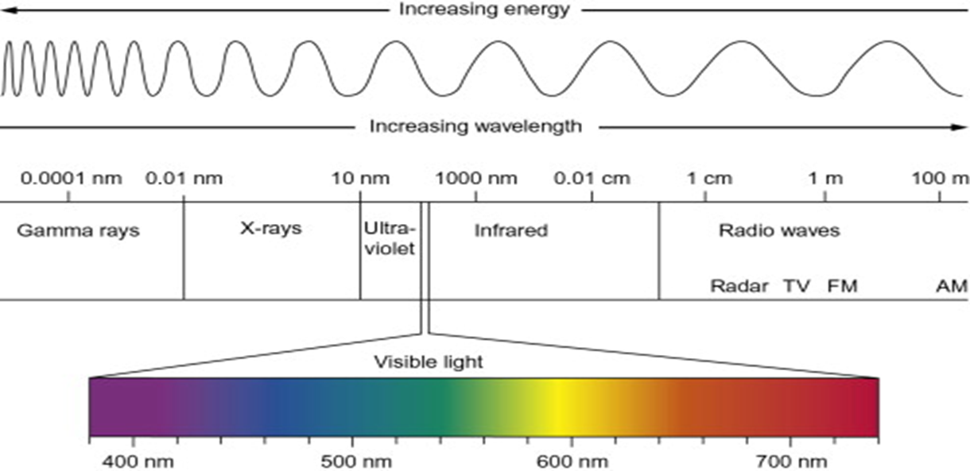

* Microwave radiation can also change the rotational energy of molecules; this effect is used to heat food quickly in a microwave oven.
* In the middle regions of the electromagnetic spectrum, absorption of IR radiation causes changes in the vibrational energy of molecules.
* Visible (Vis) and ultraviolet (UV) radiations after the electron energies of loosely held outer electrons of atoms and molecules.
* Higher-energy X rays can cause electron transitions between inner electron levels, and gamma radiation produces changes within atomic nuclei.

**WAVE THEORY**

* **All energies of the electromagnetic spectrum can be considered to be waves that move at the speed of light, with the types of radiation differing only in amplitude, frequency, and wavelength.**
* **Electromagnetic radiation can also be characterized by the number of waves per unit length. This is termed waved number, v.**
* **Frequency and wave number units have two advantages over wavelength units.**
* **The first is that they remain constant, regardless of the media traversed by the radiation, whereas the wavelength is reduced.**
* **When radiation passes through a medium with a refractive index greater than that of a vacuum.**
* **This change in wavelength due to refractive index is ignored except for high-accuracy experiments.**
* **The second advantage of the use of frequency and wave number units over wavelength is that they are directly proportional to energy.**
* **Thus, a transition that requires greater energy will occur at a higher wave number so it is used in IR spectroscopy.**

**FUNDAMENTALS OF SPECTROPHOTOMETRY**

* Electormagnetic radiation is a form of energy transferred by waves and characterized by its wavelength and frequency.

**Properties of Light:**

1. **Particles and Waves** – light waves consist of perpendicular, oscillating electric and magnetic fields; parameters used to describe light:
   1. **Amplitude (A)** – height of wave’s electric vector
   2. **Wavelength (l)** – distance (nm, cm, m) from peak to peak
   3. **Frequency (n)** – number of complete oscillations that the waves makes each second
      1. Hertz (Hz): unit of frequency, second-1 (s-1)
      2. 1 megahertz (MHz) = 10**6** s-1 = 10**6** Hz

